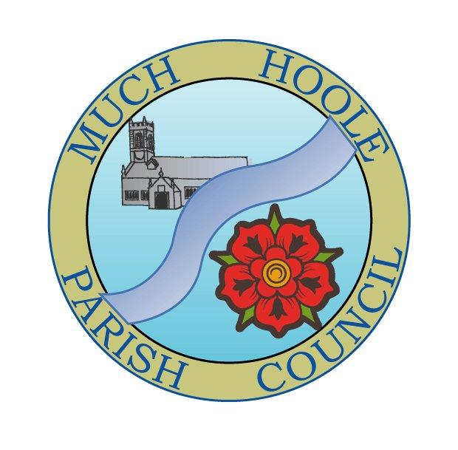 | MUCH HOOLE PARISH COUNCIL  NOTICE OF MEETING
 | You are hereby summoned to attend the Meeting of Much Hoole Parish Council to be held at 7.30pm on Monday, 17th April 2023 preceded by the Annual Parish Meeting at 7.15pm. The meetings will both be held at the Venue (Hoole Village Memorial Hall) Liverpool Road. Produced by Richard Lea on behalf of Russ Weaver, Clerk.
AGENDA
1. | Apologies for Absence  To receive apologies for absence. P Cocker and R Weaver.
2. | Declaration of Interests and Dispensations  - To receive declarations of interest from Councillors on items on the agenda  - To receive written requests for dispensations for disclosable pecuniary interests (if any)  - To grant any requests for dispensation as appropriate
3. | Minutes of the Previous Meetings  To resolve to approve a correct record of the Minutes of the Council Meeting held on the 13th March 2023.
4. | Public Time  To invite and listen to issues raised by members of the public.
5. | Reports from other meetings  The Council will receive reports from meetings where Councillors have attended as representatives.
6. | Off Road Cycle Track  To consider any updates on the Cycle track and resolve any actions required.
7. | Finance and Audit  To resolve to authorise payment of the following:  - Pay LALC Membership for year April 2023 – March 2024 in the sum of £366.35.
8. | Community Projects  - Review progress on summer planting  - Review progress on replacing the tyre planters with stone trough planters  - Review progress on the Road Safety panels on the three Village signs and involving Much Hoole Junior School in designing posters.
9. | Forthcoming Clerk vacancy  - To review applications received and set a date for interviews by the panel of three councilors and discuss the selection, appointment and handover process.
10. | Village Hall development update  - To receive and note a report on the progress of The Venue  - Review progress on installing a bench at the Village Hall.
11. | Planning  To review the application from last month’s meeting:  07/2022/00797/FUL Ward Application No. Address Description Applicant Category Case Officer Hoole 07/2023/00133/PIP  The Blossoms, Town Lane, Much Hoole, Preston, Lancashire, PR4 4GJ Permission in principle for up to 2 dwellings. Review of progress on communication with SRBC Planning.
12. | SRBC housing policy  To discuss SRBC / Housing Association placement policy – may not need discussion again.
13. | Forthcoming Council elections  To review any issues arising and agree the agenda for the AGM to be held prior to the next Council meeting.
14. | Coronation celebrations  To consider the forthcoming four local coronation events and whether any subsidies should be awarded.
15. | Remembrance Day  To consider what celebrations and arrangements should be put in hand.
16. | Community Garden  To consider whether we do this, where this should be located and how it should be set up and managed.
17. | Footpaths  To review progress on FP11 and FP22 and consider the need for repairs to the second stile on FP11 at a cost of £50.
18. | Grants  To consider the grant request as a follow up to the application submitted by St Michael’s Church for £500 towards the initial cost of setting up their Youth work in the village which is to be launched on 26th April.
19. | Items for next agenda
20. | Date of Next Meeting  The Parish Council to agree the date of the next meeting as 7.30pm Monday 15th May 2023, to be held at ‘The Venue’, Liverpool Road, Much Hoole. This meeting will be preceded by the AGM of the Council at 7.15pm.

